The URL of the site is https://thesakeris.global/
The URL to log in as admin is https://thesakeris.global/wp-admin/
If you give me a direct mail address I will give you the admin login credentials.

This is the test post I have been using:

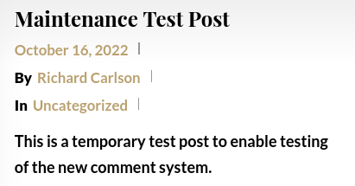
The URL of this post is https://thesakeris.global/2022/11/10/maintenance-test-post/

First I cleared the cache in Firefox.

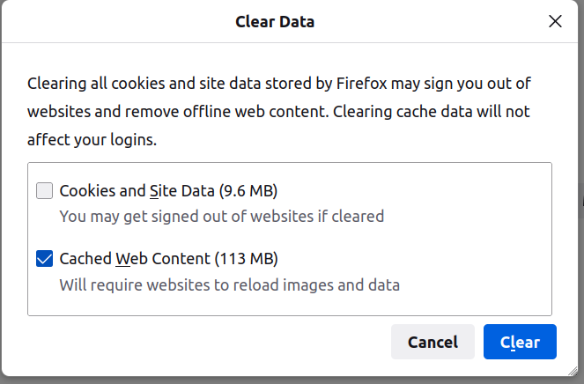
Then I entered the test comments below.

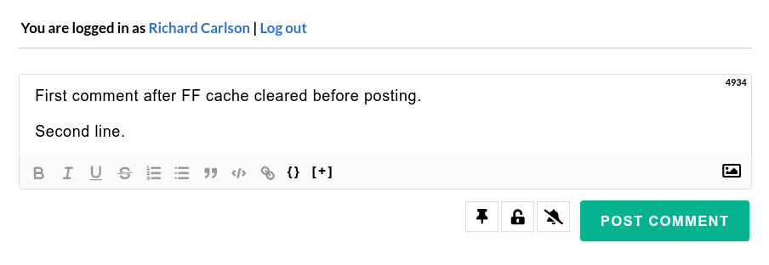
Second comment before posting:

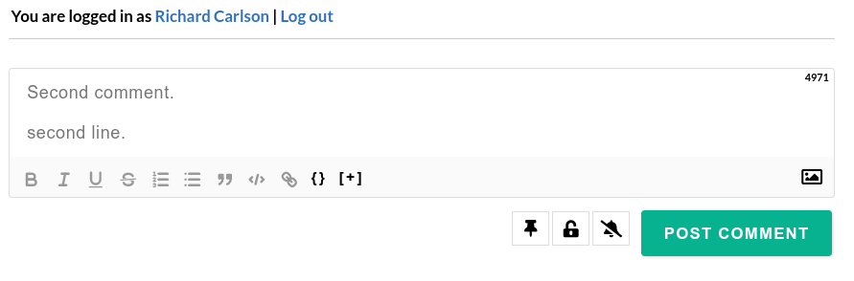

Comments as they appear after posting:
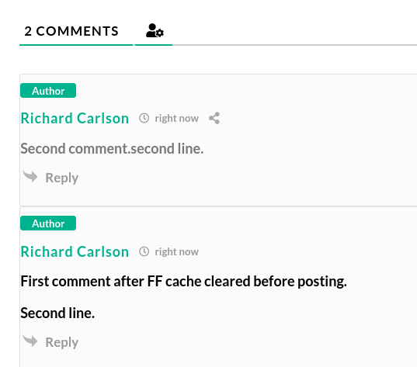
As you can see the second comment (and any comment thereafter) is jammed together on one line.

This happens with any length of comment..

